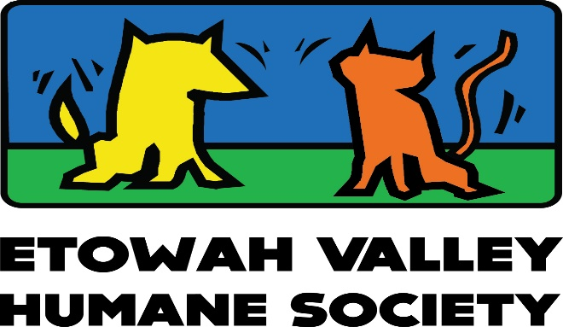
“Where Best Friends Meet”
36 Ladds Mountain Road
Cartersville, GA 30120
Phone: (770) 383-3338 * Fax: (678) 721-6953
www.etowahvalleyhumane.org
EVHS CODE OF CONDUCT:
As a corporate officer of GA Dept of Agriculture licensed companion animal rescue organization (“rescue”), _________________________________________________________________________, I, _______________________________________, understand that those associated (board members, staff, and volunteers) with the aforementioned “rescue” act as authorized agents and that the “rescue” assumes all liability as it pertains to the agent’(s) conduct while transacting business with Etowah Valley Humane Society (EVHS). While operating under the “rescue” license, any and all agents will conform to the following code of conduct:
- Agent of rescue to comply with all requests made by agents of EVHS and/or Bartow County Animal Control (BCAC).
- Absolutely NO personal attacks on staff of BCAC or EVHS. This includes social media!
- Absolutely NO profanity to be used while on the premises of EVHS or BCAC.
- Absolutely NO unauthorized photography or videos taken without express permission of BCAC/EVHS.
- Agent to remain in lobby or parking lot while on BCAC premises.
- Rescue responsible to inform agents of providing materials (crates/leashes) to properly restrain animals being transported.
- Absolutely NO intervention of “rescue” to circumvent BCAC intake protocols as they pertain to abandoned/strayed animals.

Signed ______________________________________________________ Date ____________________
Animal rescue requires the cooperation of many individuals and entities working TOGETHER for the benefit of the great homeless pets of Bartow. In order to do so effectively, all parties involved must understand and respect the value of the others. As EVHS holds transferring rescues partners to this code of conduct, ALL agents of EVHS will comply as well.
Bryan K. Canty
Bryan K. Canty
Director, EVHS

